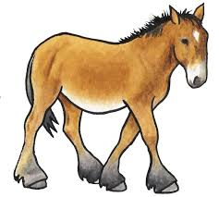 Equine Voices Sale and Breeding Policy

Dear _____________________,
All of us at Equine Voices Rescue & Sanctuary would like to thank you for participating in our adoption program. Our rescue efforts are made possible by people like you that open their homes to equines in need.

Equine Voices intends for all horses, burros and mules adopted through our program to be safe and in a family that has made a lifelong commitment to them. They are ready for their forever home.

As an adopter, I agree to the following policies:

- No animals adopted from Equine Voices shall be sold or traded. If for any reason the adopted animal(s) will no longer be residing with the named adoptive family, they must be returned to the sanctuary if the adoptive family can no longer care for them. Equine Voices retains the first right of refusal on all animals for their lifetime. This is clearly outlined in the adoption paperwork. Equine Voices needs immediate notification so that arrangements can be made for their safe return to the sanctuary.

- Equine Voices takes a strong position regarding the prohibition of use of all mares and fillies adopted from our program for breeding purposes. We ask that all adopters refrain from breeding. If this is a problem for any adopter or potential adopter, the mares will remain in the care of Equine Voices.

Equine Voices Rescue & Sanctuary requires that our adoptive parents agree to these policies.

Please sign below and return this original letter within five (5) days to the address below. Your signature indicates your acceptance of these policies.

Thank you again for your participation in our adoption program.

____________________________________ _______________________________________
Karen Pomroy Signature of Equine Adopter
Executive Director/Founder
Equine Voices Rescue & Sanctuary ________________________ _____________
Printed Name Date

(Rev. 7/2023)

